Phase 2 Class Work
TC ingestion to MongoDB
Convert excel to json
node src/scripts/data-conversion/excel-to-json.js
Create Embeddings & Store Data
node src/scripts/embeddings/create embeddings-batch-mistral.js
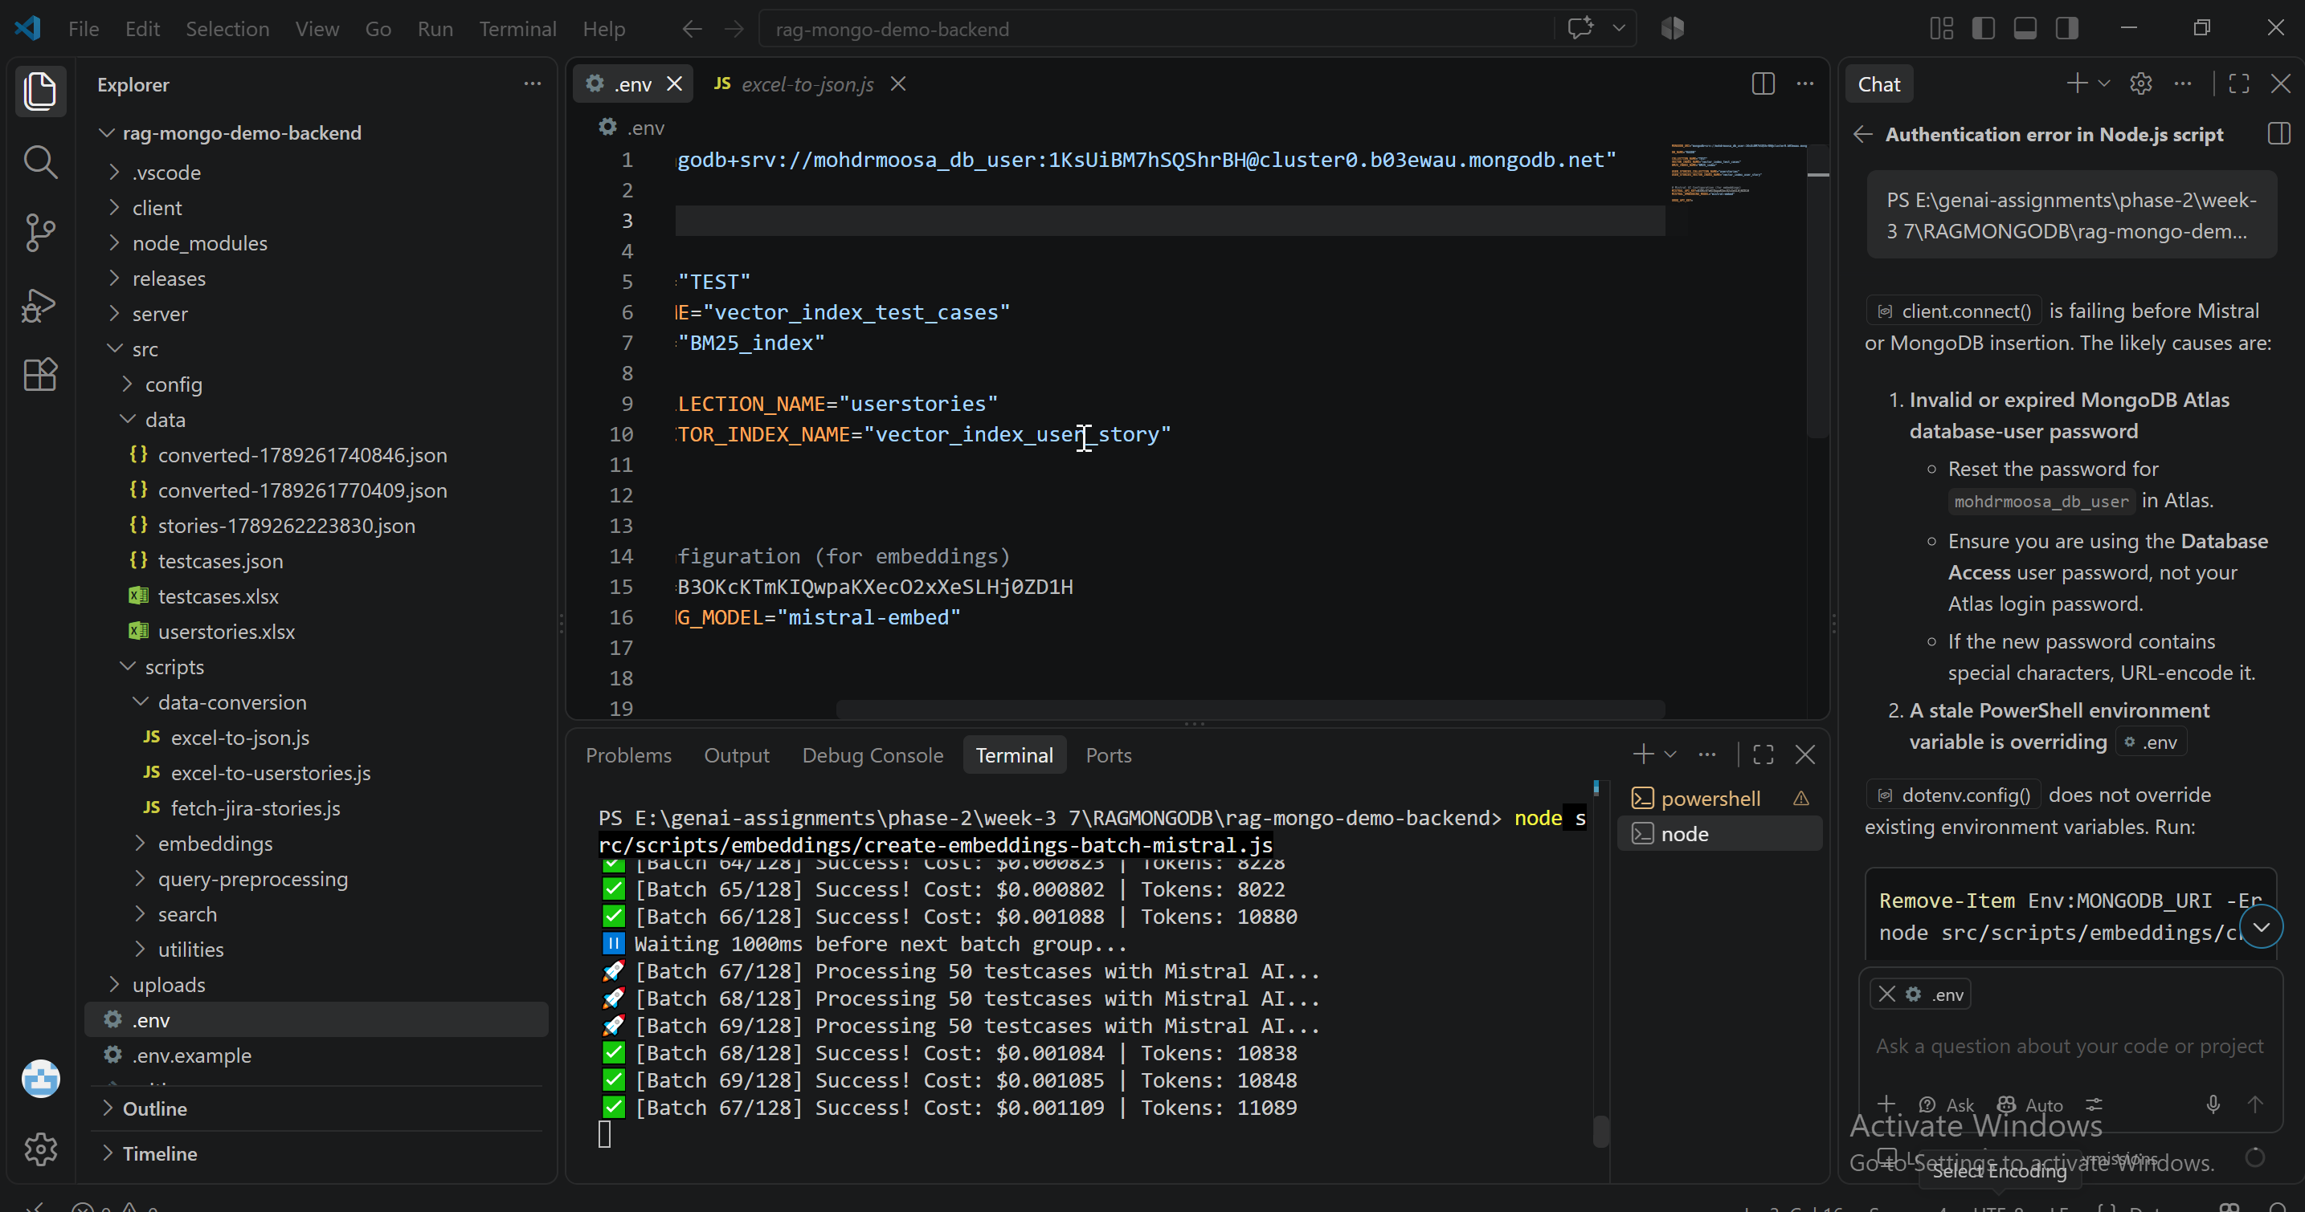
Ingested TCS to Mongo DB
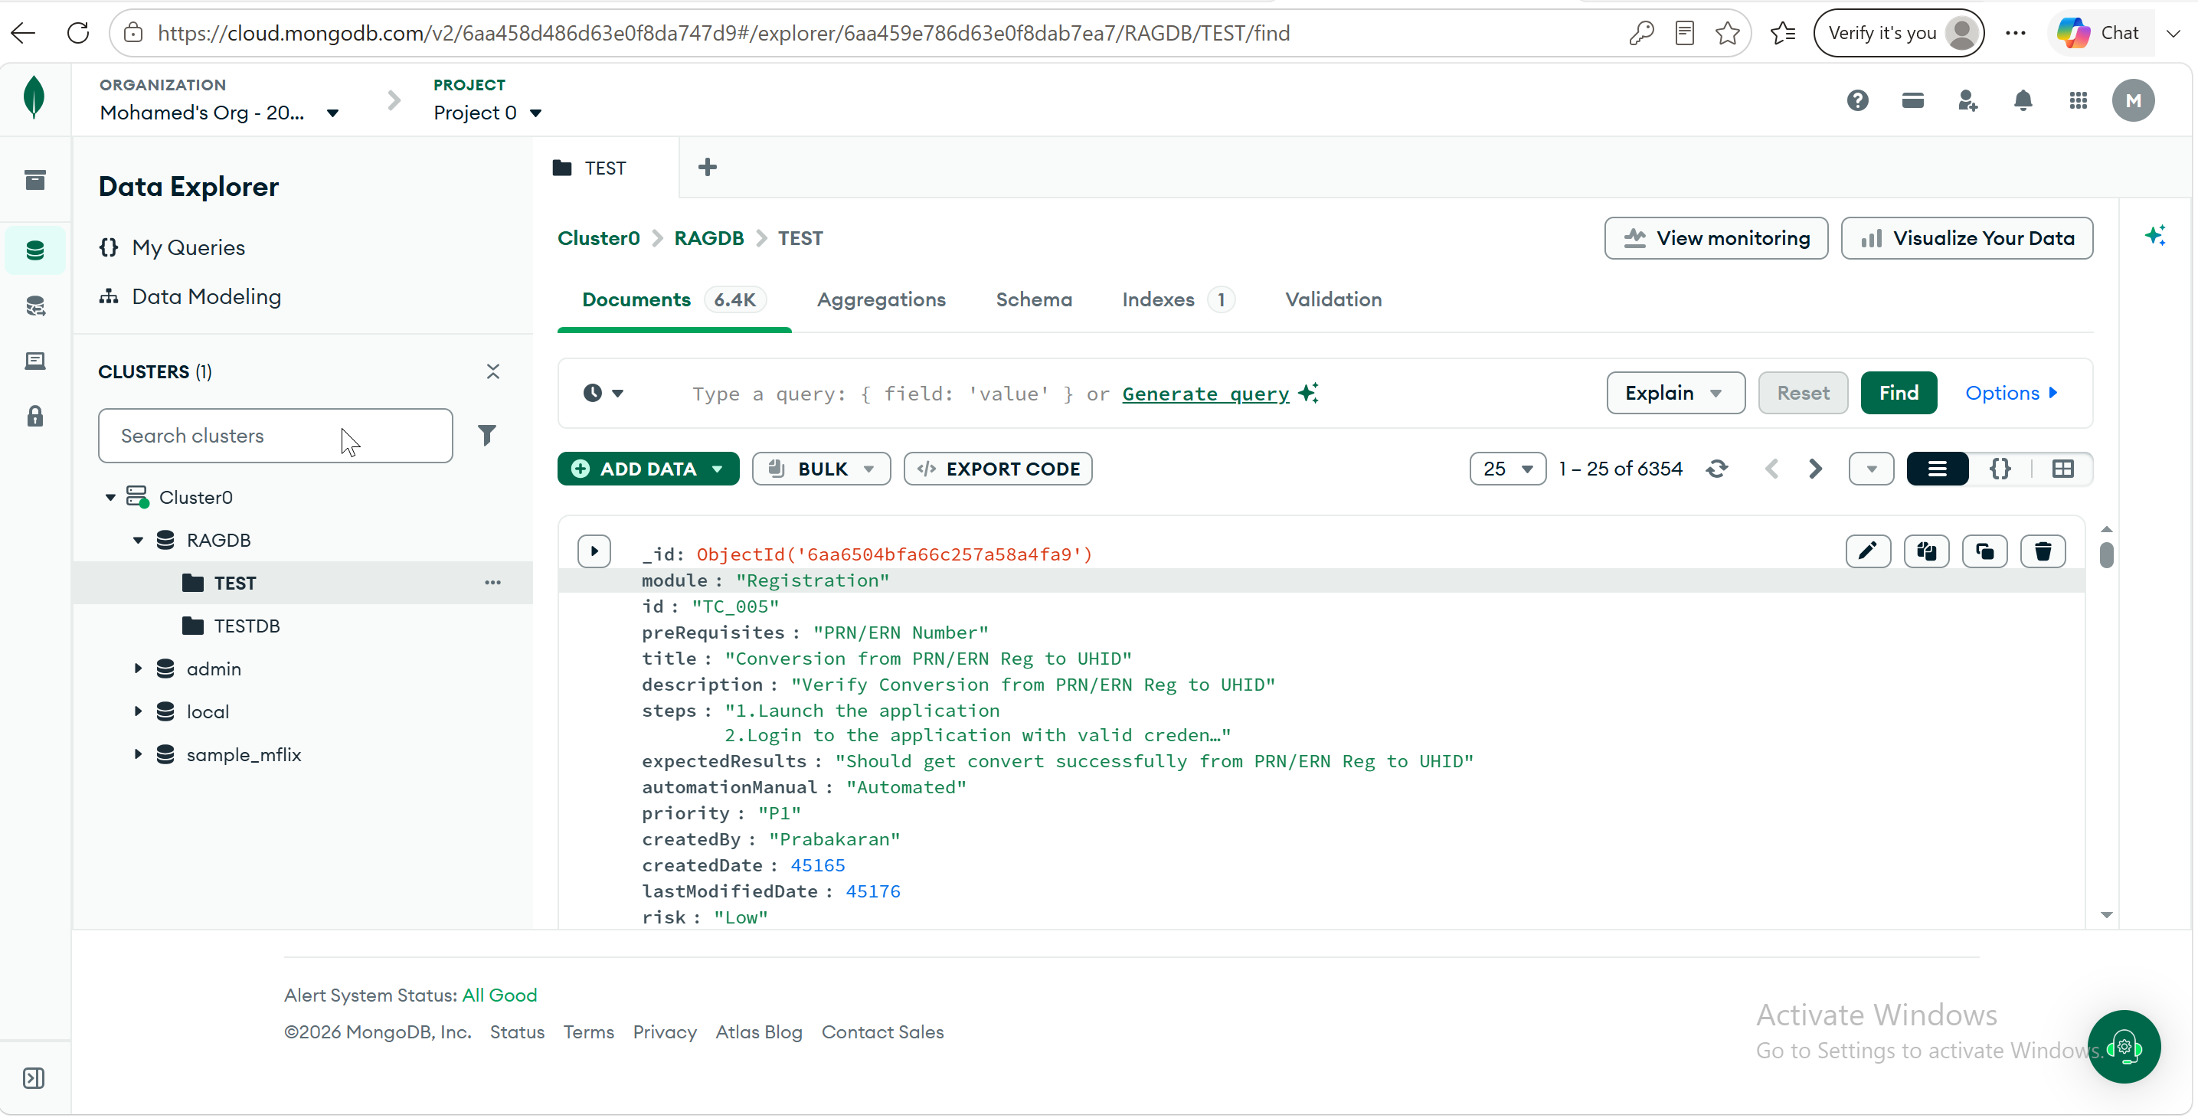

Deleted all TC’s
node src/scripts/utilities/delete-all-documents.js
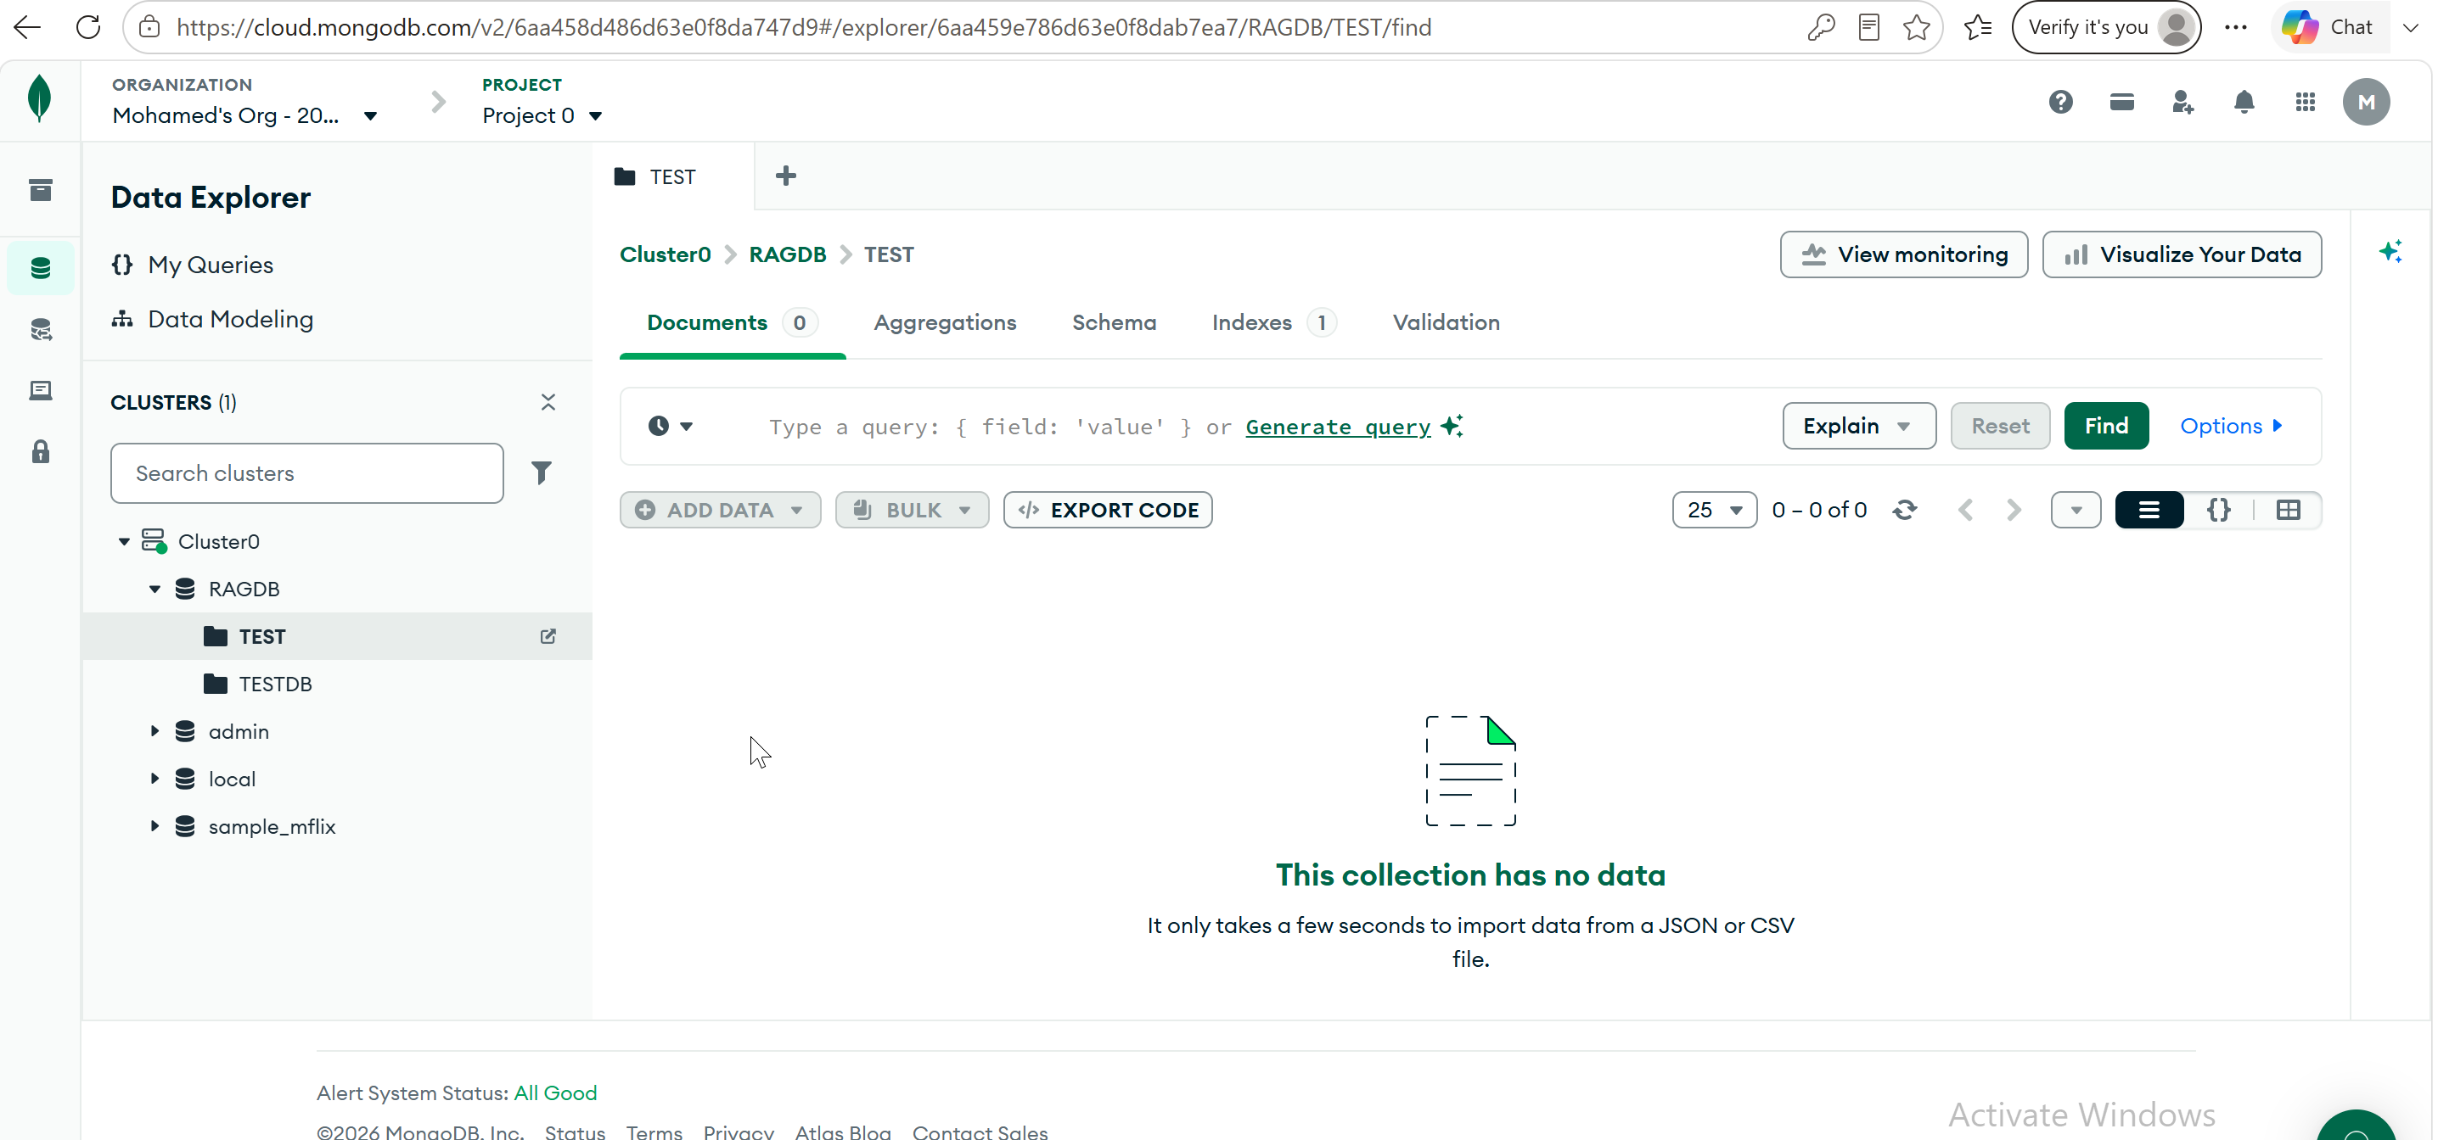

Via Postman
Health Check
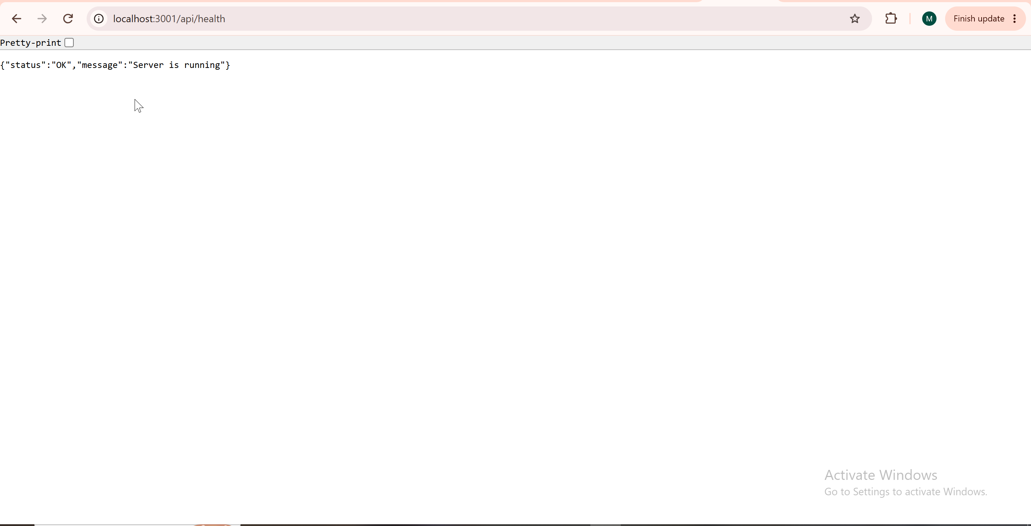
Upload Test Cases
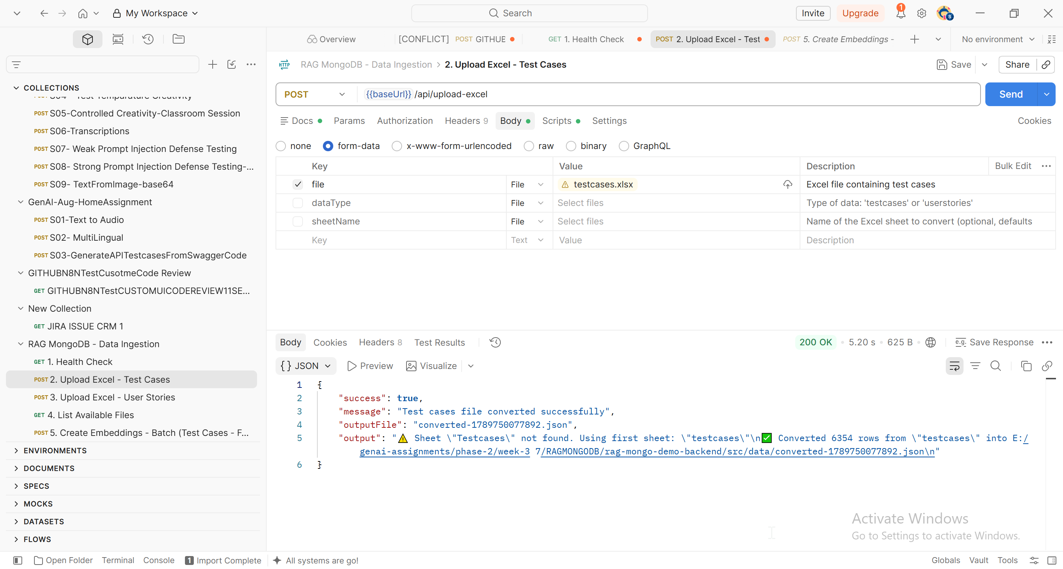
List Available Files:
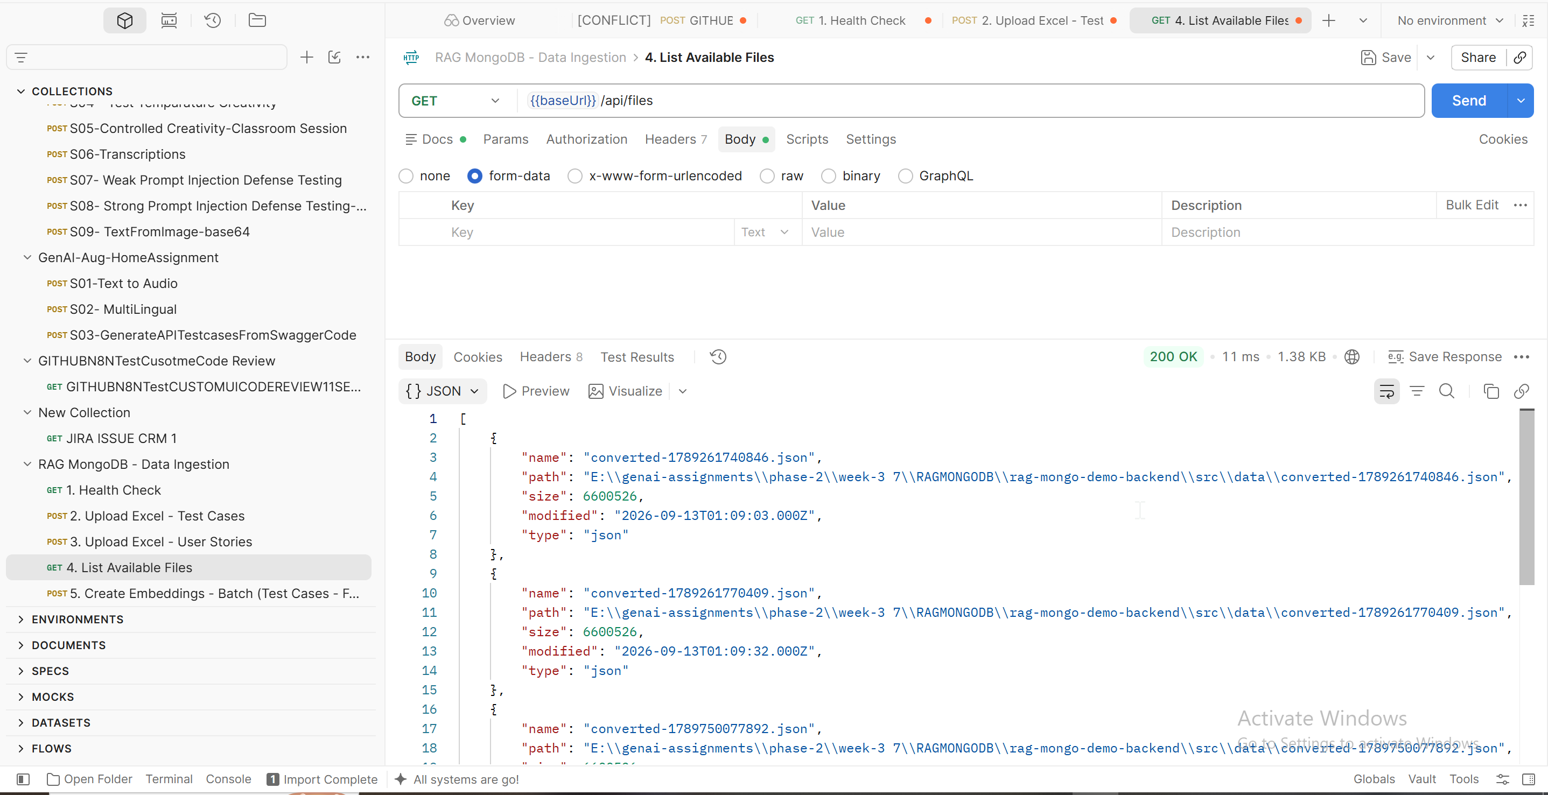
Create Embeddings: Before Clicking Send Button
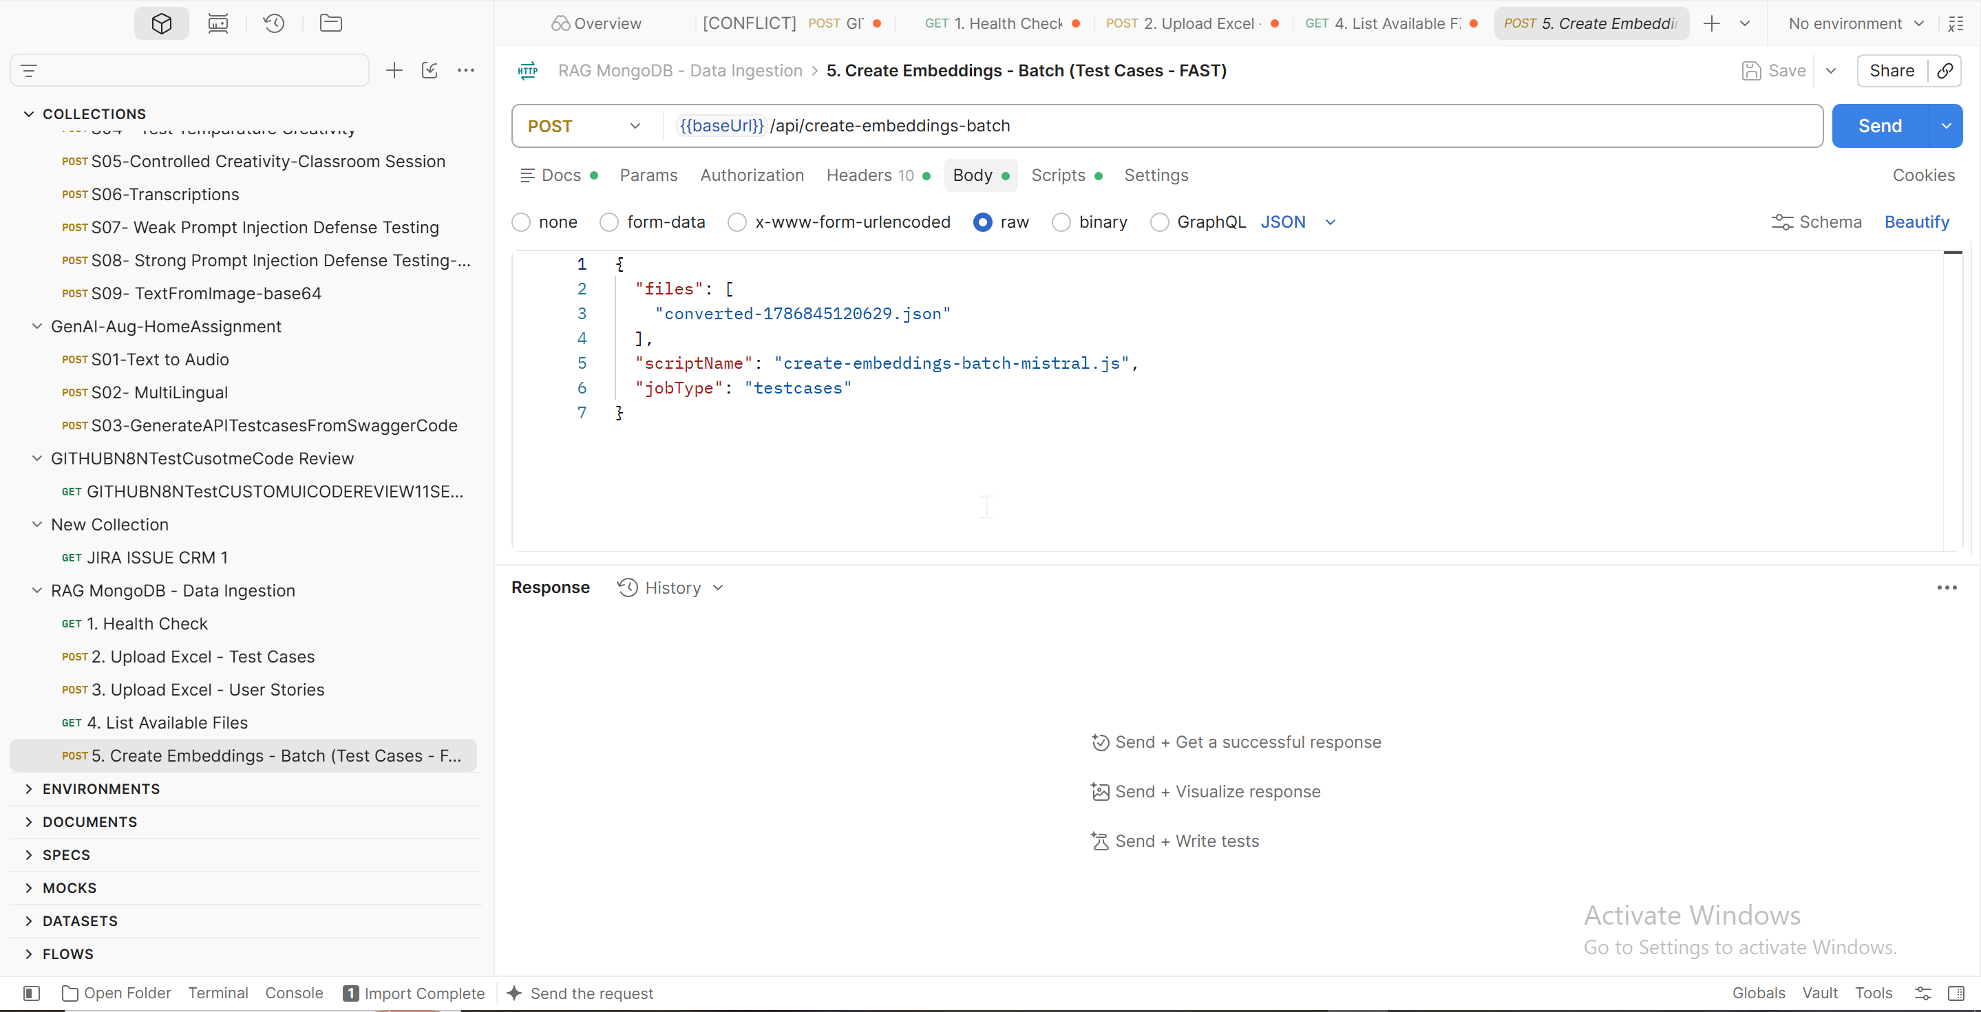
Click Send and the response
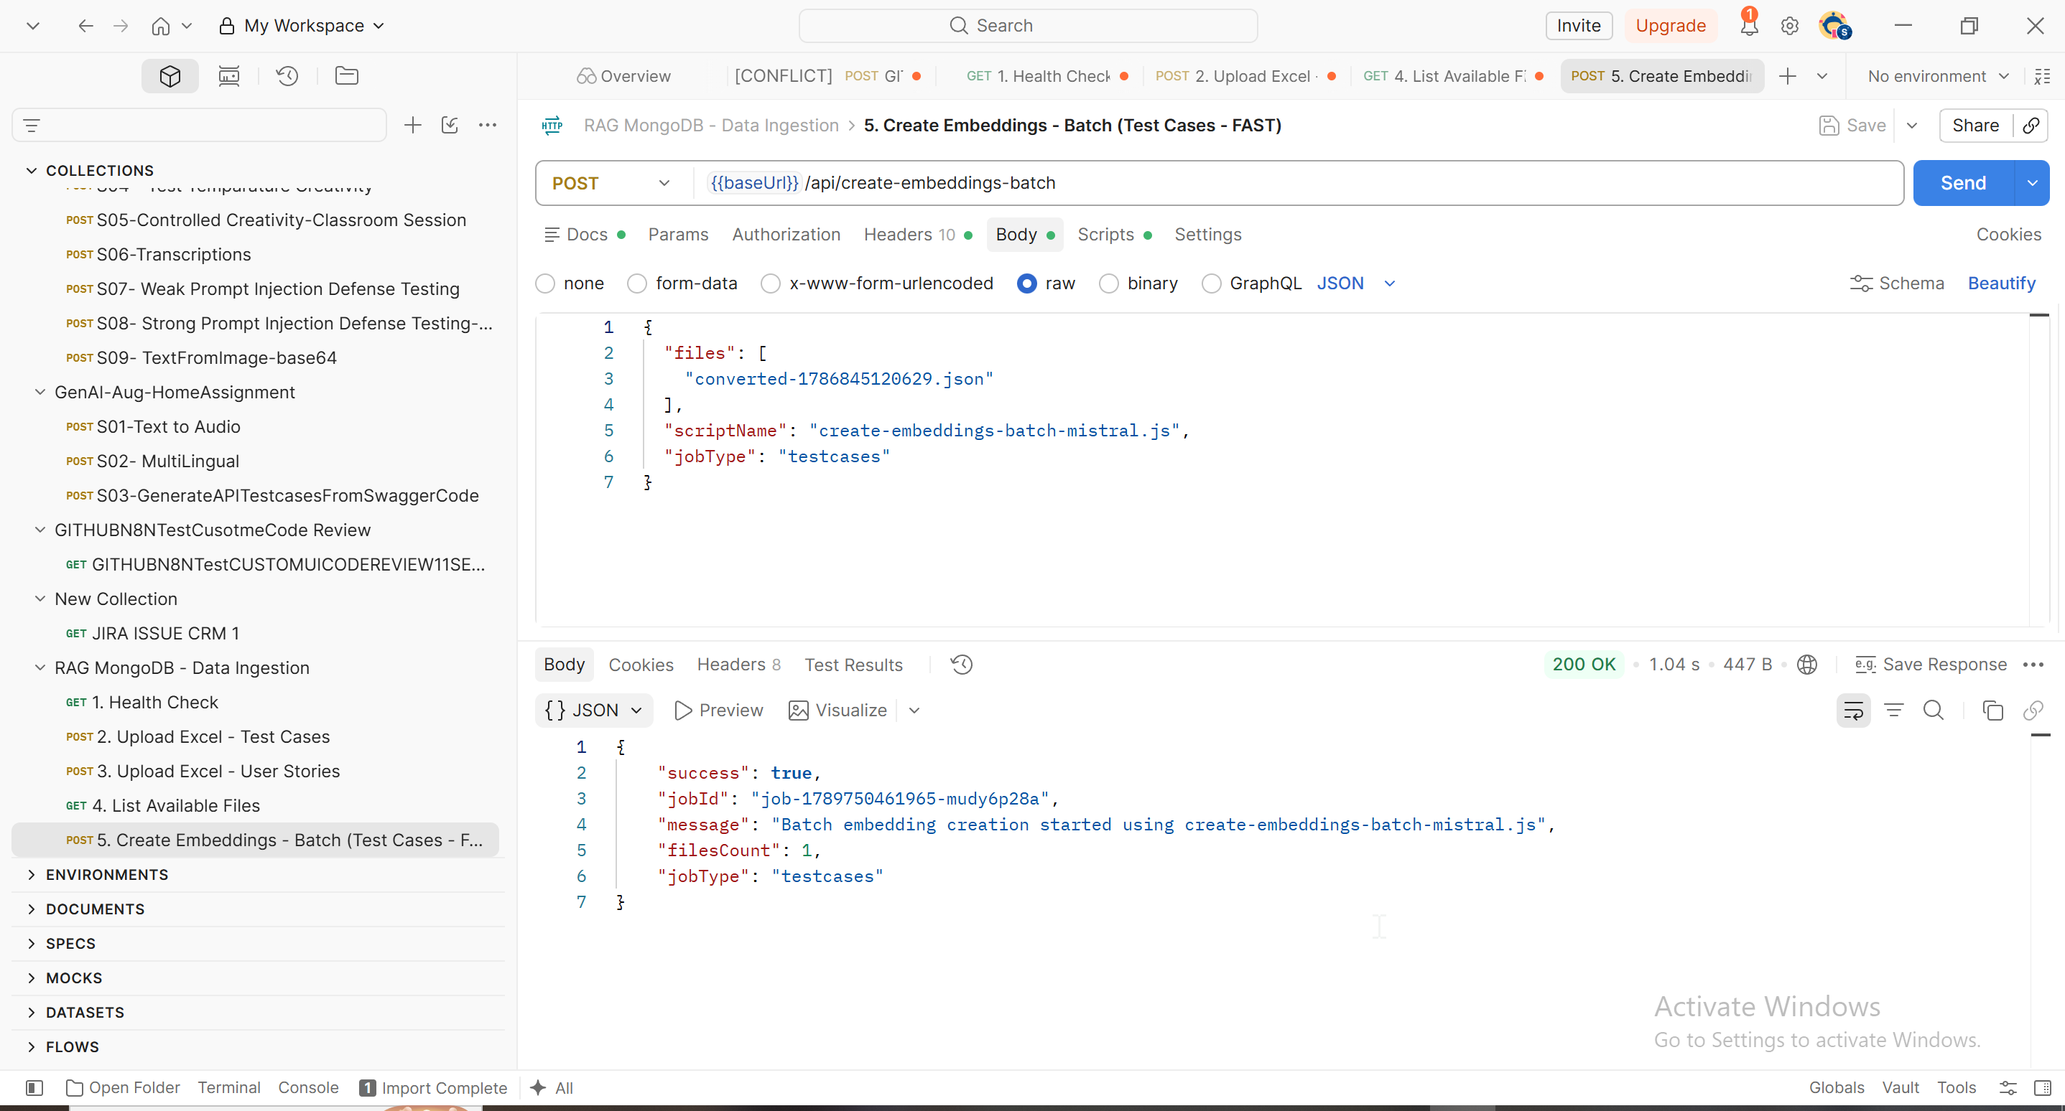
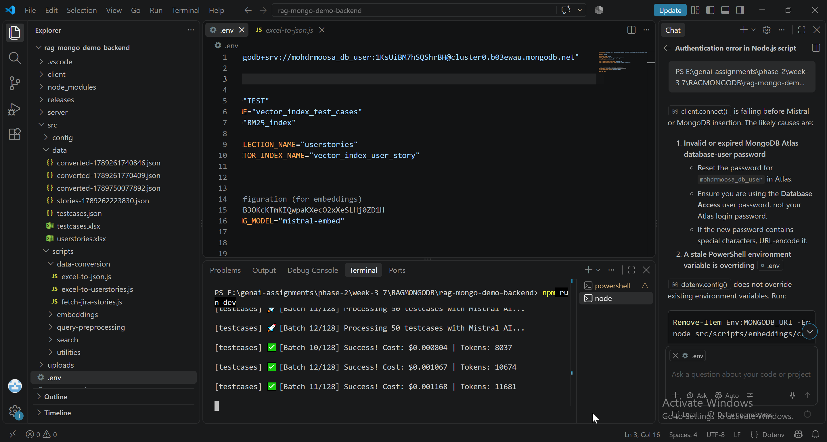
Ingested via postman:
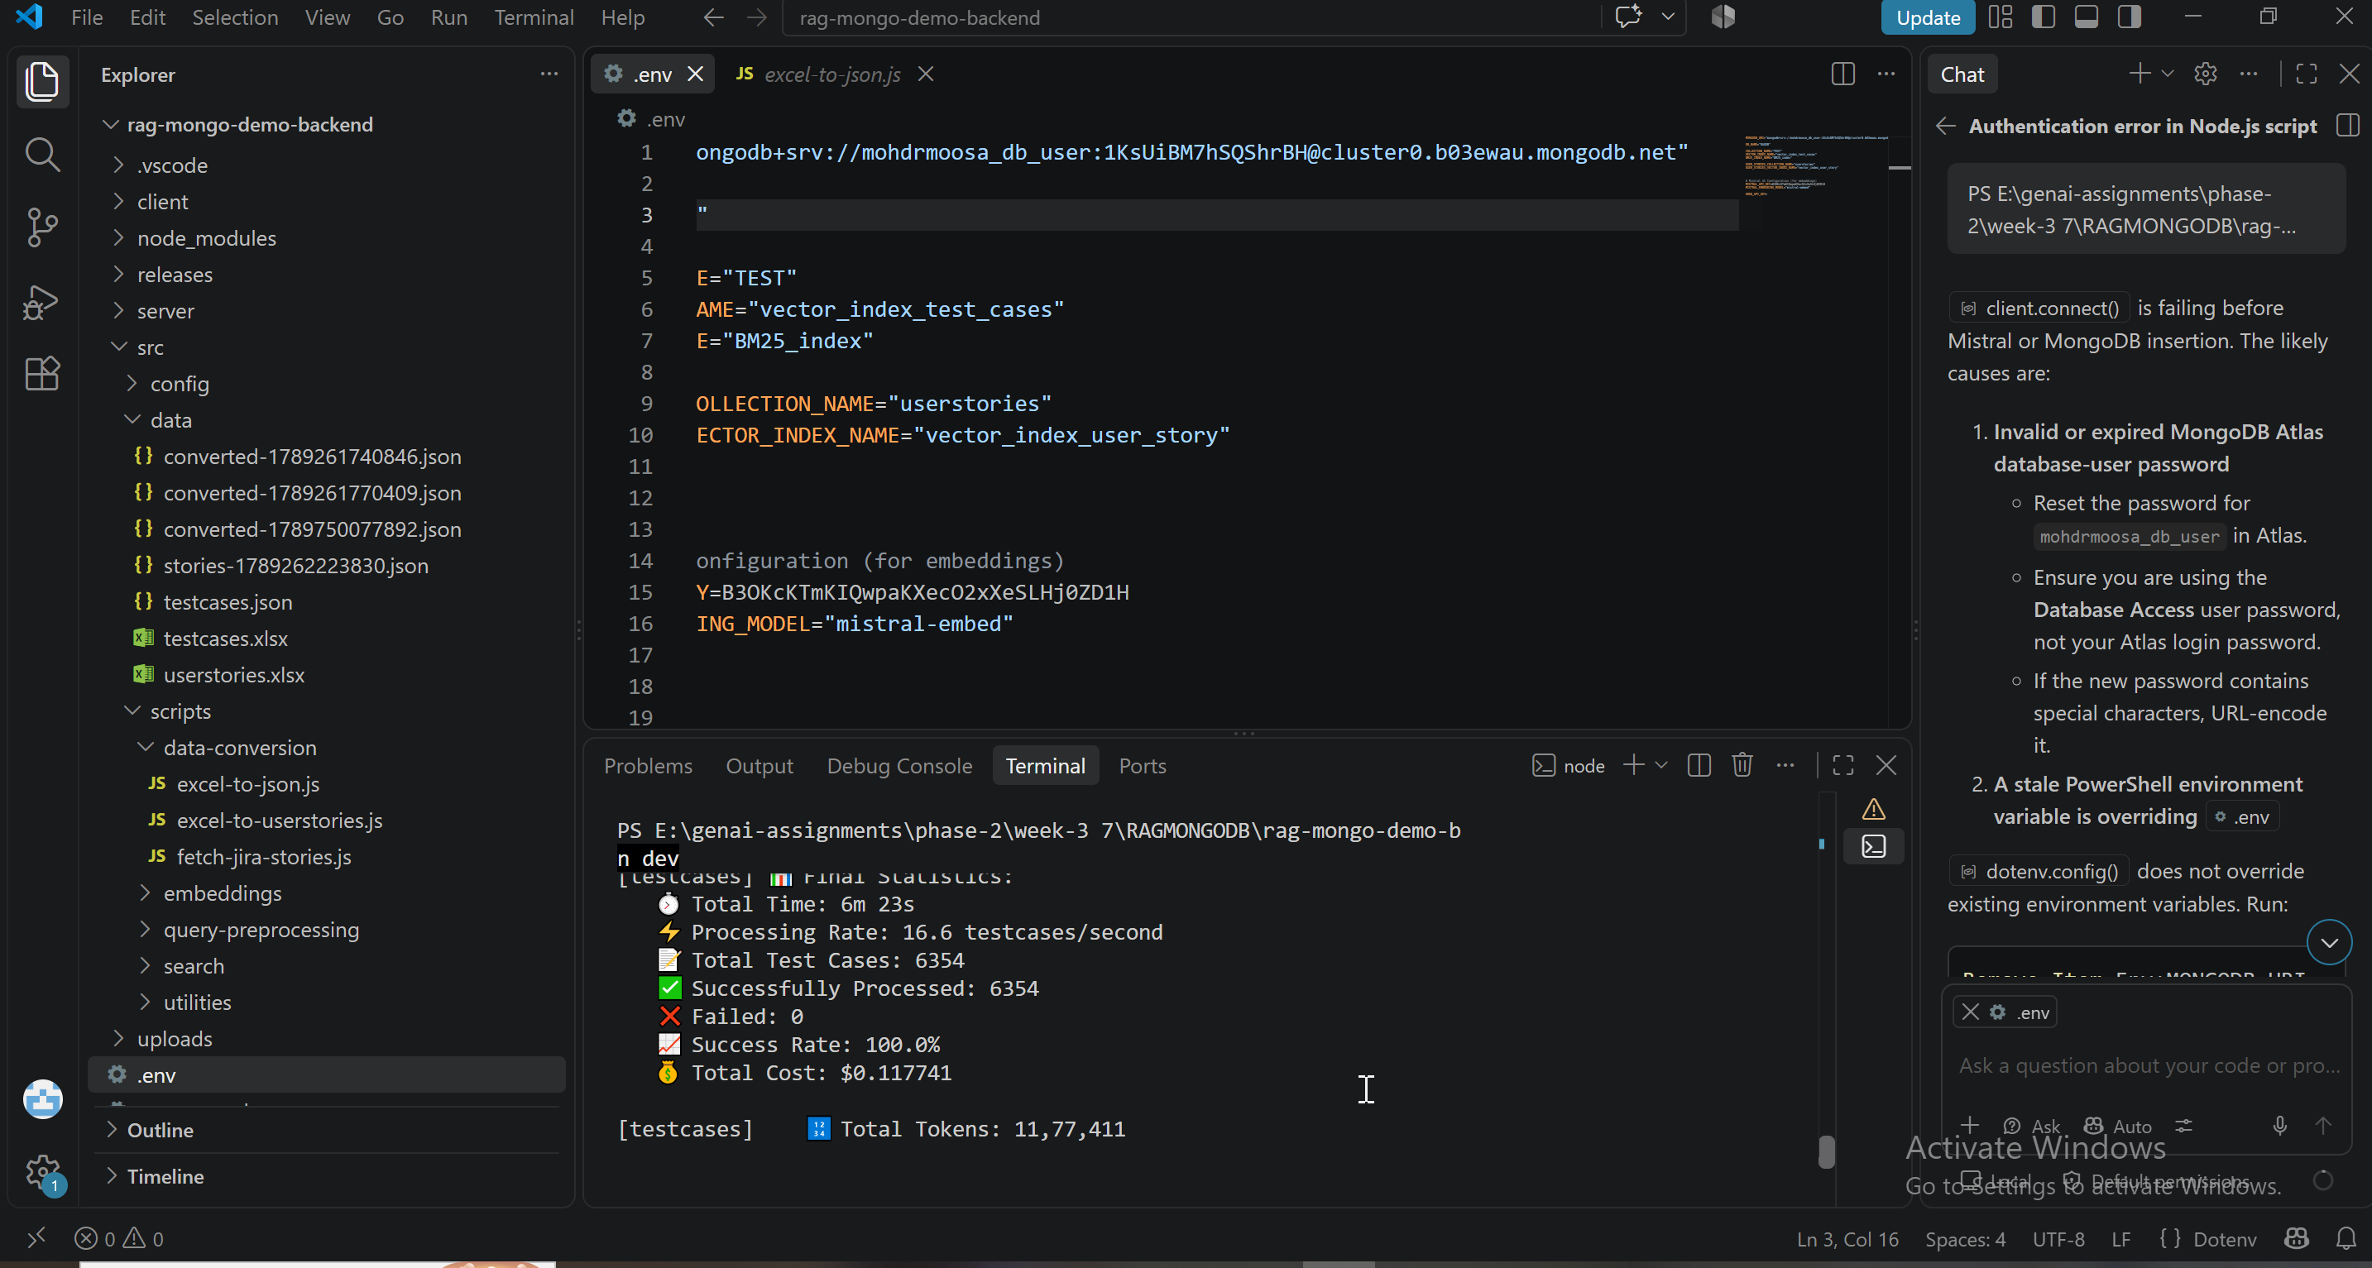
6354 TC Ingested via Postman
